

User Manual

**Table of Contents**

**Introduction and Purpose of Equipment** ………………………………...…... page 3

**OMNIA Applications** ……………………………….……………………….… page 3

**Specifications** ……………………………….……………………………….…. page 3

**Installation and Notes** ………………...…………………………………….…. page 4

**Main Unit and Parts Installation** ………….……………………………….…. page 5, 6

**Accessories List** …..………………………………………………………….….. page 7

**Handpiece Installation/ Removal** ...……………………………………….…...page 8

**Display Screen Installation** …………………………………………....….…….. page 9

**How to Input Water** …………………………………………………..….……..page 9

**How to Drain Water** ……………………………………………………..……... page 9

**How to Install Handpiece Holder** ………………………………………….….... page 10

**Power Cord and Foot Switch Connection** ……………………………...……… page 11

**Breaker Switch** ………………………………………………………………….. page 11

**Locking the Casters** ……………………………….…………………………….page 11

**Clinician/ Operator Display Instruction** ………………………………………. page 12, 13,14

**SHR Clinical Parameter Suggestion Chart** …………………………………….page 15

**SSR (IPL) Clinical Parameter Suggestion Chart** …………………………....…page 16

**Security Introduction** …………………………………………………………….page 17

**Safety** ……………………………………….…………………………………..… page 17

**Before Calling for Service Check** ……………………………………………….page 18

**How to Check or Replace the Power Fuse** ……………………………………….page 18

**Main Unit Storage and Transport Maintenance** ………………………………. page 19

**Laser Handpiece Maintenance** ……………………………………………….....page 19

**Cooling System** ……………………………………….…………..……………… page 19

**Introduction and Purpose of Equipment**

* The Omnia IPL Device comes equipped with 2 handpieces, each hand piece has the ability to target different chromophores. It successfully achieves optimum IPL results by delivering energy into the targeted chromophore through selectively absorbing the energy without causing a change to the surrounding tissue. This Omnia laser can deliver various settings to be safely and comfortably used on all skin types.
* The Omnia platform allows for the practitioner/clinician to safely and effectively treat all skin types and hair colors with one device. The Omnia IPL can treat skin types 1-4. Hair removal can treat skin types 1-6. The machine comes equipped with pre-programmed settings and protocols for patient comfort, safety and efficacious treatments.
* The Omnia IPL handpiece targets the chromophores melanin, hemoglobin, porphyrin and water. This means light energy passes the tissue into the targeted chromophore with little to no energy absorbed by the surrounding skin tissue, this makes it safer for skin containing more melanin. The distribution of heat throughout the tissue is also achieved through a customized and programmed pulse format, allowing most of the energy to be absorbed into targeted chromophore resulting in an optimal outcome.
* Remember: Light, heat, destruction. As this light energy is converted into thermal energy and targeted, it destroys the selected chromophore.

**OMNIA Applications**

**-** Hair Removal

- Hyperpigmentation Therapy

- Skin Tightening

- Vascular Legion Therapy

- Skin Rejuvenation

- Acne Clearance

- SHR Skin Rejuvenation/ Super Hair Removal

**Specifications**

| Display | 15 inch, color, touch screen |
| --- | --- |
| Power | 4000 W |
| RF Frequency | 10 MHz |
| RF Energy | 1 – 50 J |
| IPL Energy | SHR: 1 – 15J/ E-Light: 1 – 50J |
| Number of Pulses | SHR 1 T/ E- Light: 1 – 6T |
| Pulse Frequency | SHR: 1 – 10 Hz |
| Discharge Interval | E – Light: 1 – 4s |
| Number of Handpiece | 1 Handpiece |
| Spot Size | 10 mm x 50 mm |
| Lifespan of Lamp | 1 million shots |
| Cooling System | 0 ~ 10 °C |
| Voltage | 110 V ~ 240V AC |
| Machine Dimension | 470mm x 470mm x 1090 mm |
| Package Dimension | 670mm x 630mm x 1230 mm |
| Net / Gross Weight | 57 KG / 90KG |



**Installation & Notes**

* Packing the Laser

* Opening the exterior packing box:

1. Turn left the lever 180 degrees (as pictured in the photo above on the left to the position

shown in the picture on the right).

1. Switch the lever, then we can open the packing box.

# Step 1: Upon unboxing the machine, ensure that it will be placed on a flat, leveled surface.

**Step 2:** Be sure to input enough water into the machine, distilled only.

**Step 3:** Attach handpieces and lock wheels into place.

**Step 4:** After assembly, turn on the device.

**Step 5:** Verify that there is proper water circulation inside the machine.

* Listen for the water flow sound inside. Wait for 3-5minutes, till the probe turns cold.
* If there is no water circulation during use or handpiece(s) are hot, DO NOT USE. Burning may occur.
* If there is an external filter, please make sure the filter is inserted into the slot!

TIP: System alarm of water temperature: The lowest system settings of water temperature is

150C, the highest system setting of water temperature is 550C. When between

150C-550C the device will operate optimally.

**Step 6:** Test the device is in good working condition before use.

**Warning:** The machine must rest every 2-3 hours after continuously being operated.

The handpieces are fragile, please take special care when holding or hanging them on the handpiece holder.

When starting a treatment, begin with the energy level low and raise the

energy level during treatment as required to obtain desired results.

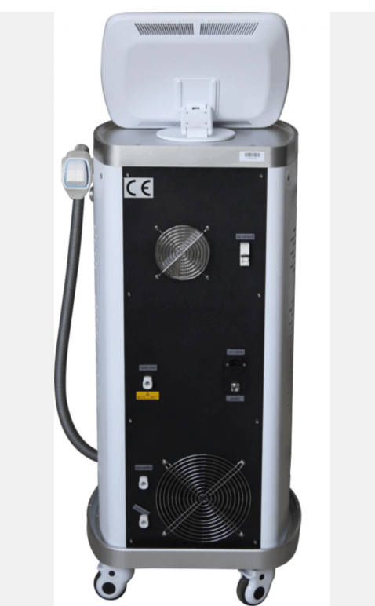

Power switch

Serial Number

## Accessories List

* + The blow chart depicts what is included with the main unit and accessories of the Invikta.

|  | Name | Photo | Qty. |
| --- | --- | --- | --- |
| 1 | Handpiece |  | 2 |
| 2 | Water Funnel | 23 | 1 |
| 3 | Pedal（Reserve） | 59 | 1 |
| 4 | Protective Goggles | 68 | 1 |
| 5 | Protective Glasses | 106 | 1 |
| 6 | Power Cord | **QQ图片20200520142258** | 1 |
| 7 | Fuse | 保险丝 | 2 |
| 8 | Water Connector | 2.jpg | 2 |
| 9 | Holder |  | 1 |
| 10 | Aluminum Alloy Box |  | 1 |

# Accessory Installation

# Installation of Handpiece

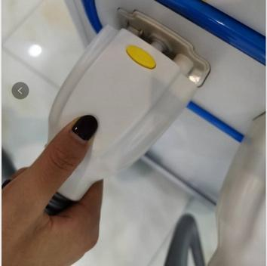

* **Removal of Handpiece** 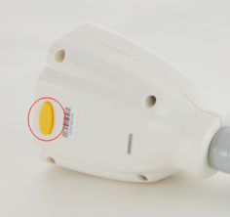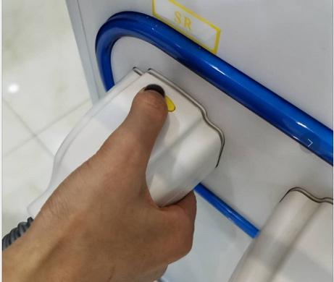
* **Display Screen Installation:**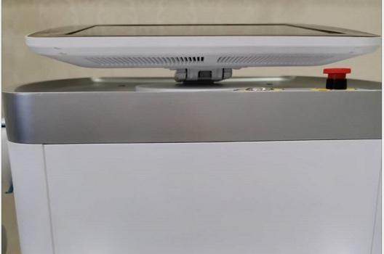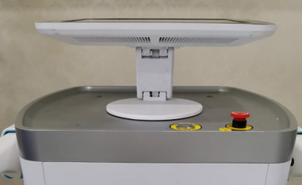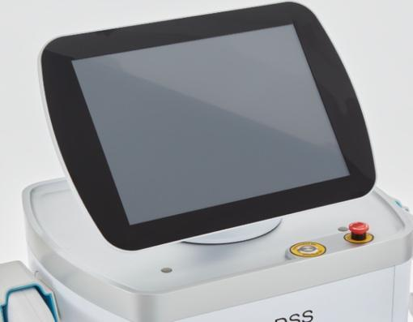

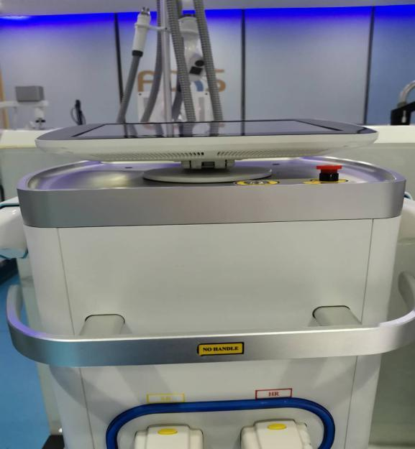

* **How to Input Water:**

TIP: When adding distilled water, plug in the CPC connector to fill the water in tank and the overflow at the same time, otherwise the water will not enter the tank input. Shown in the photos below.

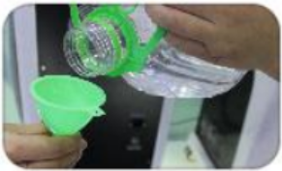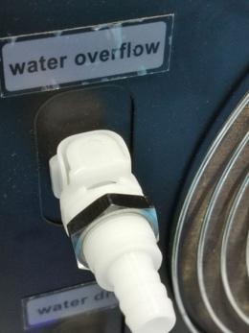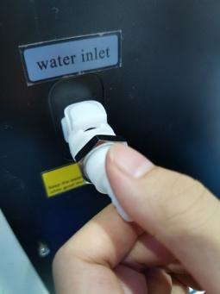

* **How to Drain Water:**

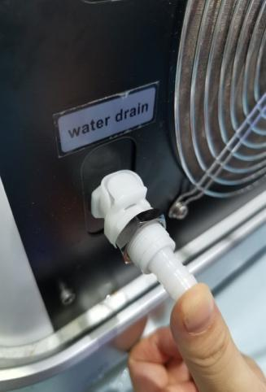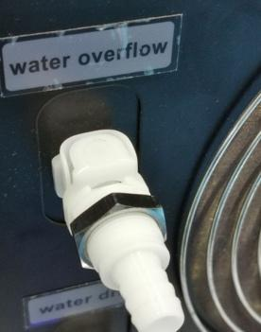

* **How to Install Handpiece Holder:**

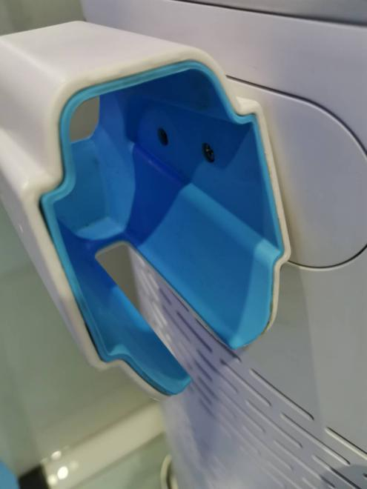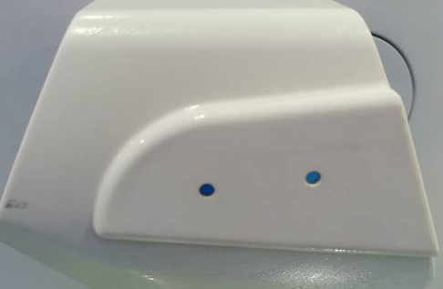

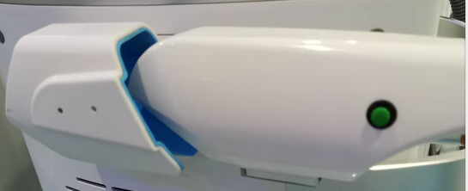

* **Power Cord and Foot Switch Connection:**

As shown in the below photos:

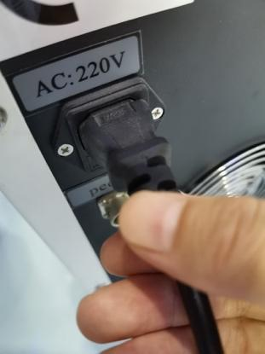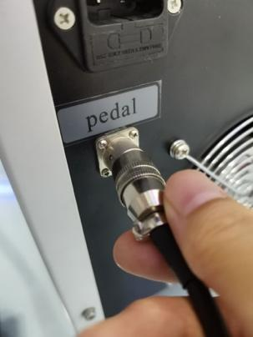

Power Cord Input Footswitch Connection Point

* **Breaker Switch:**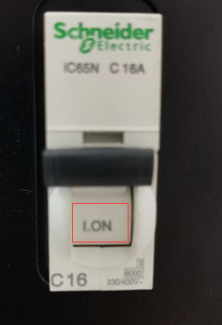

Turn on the air switch as in the following photo.

It should always “ON” when the machine is

working

* **Locking the Casters:**

Place the machine where desired and press down firmly on the caster pedals as shown in the picture.

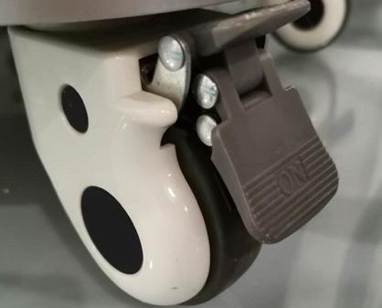

* 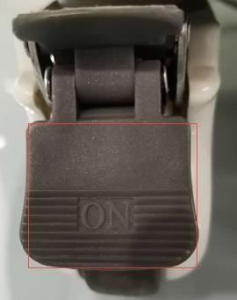

TIP: The machine Installation precautions include:

- Unpack and put the machine in a pre-selected location.

- Check the integrity of the machine and its components.

- Check whether the connection power is well grounded.

- When installing the handpiece, be sure the cord is

completely connected.

- Test all functions of the equipment are normal.

## Clinician/ Operator Display Instruction:

* Power on machine
* Enter through the login page
* Touch display, enter selection on the

function page.



* Interlock safety alarm button: Confirm the interlock safety alarm button is turned on.



* Water level indicator: Make sure the water level indicator is set at the appropriate level (that it is neither too high or too low).



- Water flow cooling button.



- Temperature gauge.

* SHR/ SSR Omnia machine has multiple protection functions including: **water flow, water level, water temperature**. When there is abnormal condition in the main unit, the system will disconnect the laser power and display itself in the way of indicators from the protecting designator of touch screen (under the normal circumstances, the indicator shows green, in the event of a failure, the indicator shows red), at the same time, the buzzer will make continuous alarm sound. Once the fault clearance is detected, the alarm screen and the alarm sound will automatically disappear. During treatment, if the same warning screen appears more than three times, please contact the Aesthetika personnel for maintenance.

**

* **SHR=** Super Hair Removal
* **IPL=** IPL Technology (SSR) Super Skin Rejuvenation

- Settings Button

- Chromophore Selection Menu

## 

- Language Selection Button

- Language Selection Menu (WRONG PHOTO REPLACE)

- Touch-tone ON/OFF

- Clock setting, Methods: Touch clock button, use number keys to input hours and

save. Use number keys to input minutes and save. Use number keys to input seconds

and save.

- Main Interface Display: handpiece will light up.

- SHR System Display

- Fitzpatrick Skin Type

Selection Screen

- Pulse Counter for Treatment

- Cooling Level Display

- Treatment Parameter Save Button

- “Ready” Mode Button. When in ready mode signals initiation of treatment.

- Return/ Back Button

- Energy Adjustment Setting, from 0 - 15 J/cm2

- Frequency Adjustment Setting, from 0 - 10 Hz

## 

## SHR Clinical Parameter Suggestion:

| **Setting**  **Function** | | **Energy** | **Frequency** |
| --- | --- | --- | --- |
| **Hair removal** | **Ⅰ** | **6J↑** | **5Hz↑** |
| **Ⅱ** | **5J↑** | **5Hz↑** |
| **Ⅲ** | **4J↑** | **4Hz↑** |
| **Ⅳ** | **3J↑** | **4Hz↑** |
| **Ⅴ** | **2J↑** | **3Hz↑** |
| **VI** | **1J↑** | **2Hz↑** |
| **Vascular Therapy** | **Ⅰ** | **6J↑** | **5Hz↑** |
| **Ⅱ** | **5J↑** | **5Hz↑** |
| **Ⅲ** | **4J↑** | **4Hz↑** |
| **Ⅳ** | **3J↑** | **4Hz↑** |
| **Ⅴ** | **2J↑** | **3Hz↑** |
| **VI** | **1J↑** | **2Hz↑** |
| **Skin rejuvenation** | **Ⅰ** | **6J↑** | **5Hz↑** |
| **Ⅱ** | **5J↑** | **5Hz↑** |
| **Ⅲ** | **4J↑** | **4Hz↑** |
| **Ⅳ** | **3J↑** | **4Hz↑** |
| **Ⅴ** | **2J↑** | **3Hz↑** |
| **VI** | **1J↑** | **2Hz↑** |
| **Pigmentation Therapy** | **Ⅰ** | **6J↑** | **5Hz↑** |
| **Ⅱ** | **5J↑** | **5Hz↑** |
| **Ⅲ** | **4J↑** | **4Hz↑** |
| **Ⅳ** | **3J↑** | **4Hz↑** |
| **VI** | **2J↑** | **3Hz↑** |
| **Acne Removal** | **Ⅰ** | **1J↑** | **2Hz↑** |
| **Ⅱ** | **6J↑** | **5Hz↑** |
| **Ⅲ** | **5J↑** | **5Hz↑** |
| **Ⅳ** | **4J↑** | **4Hz↑** |
| **VI** | **3J↑** | **4Hz↑** |
| **Ⅰ** | **2J↑** | **3Hz↑** |

**SHR “In-motion” treatment.**

* Continue on to SSR (IPL) handpiece menu options if not performing SHR treatments.

**SSR**

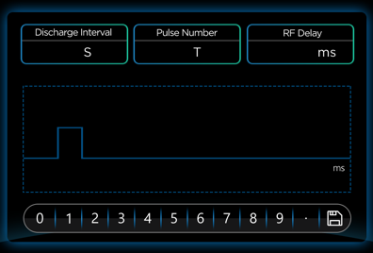 **-** Discharge interval: It’s the length of time, or interval between two sub-pulses.

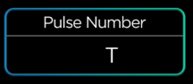

- Pulse Number Indicator. Number of continuous pulses

being delivered

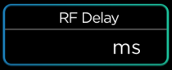

- RF Delay: 1 - 500ms, means how long RF energy

remains on skin. 500ms is longer time than 100ms

## SSR (IPL) Clinical Parameter Suggestion:

| **Setting**  **Function** | | **IPL Energy** | **RF** | **Pulse Number** | **RF delay** |
| --- | --- | --- | --- | --- | --- |
| **Hair removal** | **Ⅰ** | **7J↑** | **4J↑** | **2-3** | **100-500ms** |
| **Ⅱ** | **6J↑** | **4J↑** | **2-3** | **100-500ms** |
| **Ⅲ** | **4J↑** | **4J↑** | **3-4** | **100-500ms** |
| **Ⅳ** | **3J↑** | **2J↑** | **1-2** | **100ms** |
| **Ⅴ** | **2J↑** | **3J↑** | **1** | **100ms** |
| **VI** | **1J↑** | **3J↑** | **1** | **100ms** |
| **Vascular Therapy** | **Ⅰ** | **4J↑** | **3J↑** | **2-3** | **100ms** |
| **Ⅱ** | **4J↑** | **3J↑** | **2-3** | **100ms** |
| **Ⅲ** | **4J↑** | **3J↑** | **3-4** | **100ms** |
| **Ⅳ** | **3J↑** | **2J↑** | **1-2** | **100ms** |
|  |  |  |  |  |
|  |  |  |  |  |
| **Skin Rejuvenation** | **Ⅰ** | **4J↑** | **3J↑** | **2-3** | **100ms** |
| **Ⅱ** | **4J↑** | **3J↑** | **2-3** | **100ms** |
| **Ⅲ** | **4J↑** | **3J↑** | **3-4** | **100ms** |
| **Ⅳ** | **3J↑** | **2J↑** | **1-2** | **100ms** |
|  |  |  |  |  |
|  |  |  |  |  |
| **Pigmentation Therapy** | **Ⅰ** | **4J↑** | **3J↑** | **2-3** | **100ms** |
| **Ⅱ** | **4J↑** | **3J↑** | **2-3** | **100ms** |
| **Ⅲ** | **4J↑** | **3J↑** | **3-4** | **100ms** |
| **Ⅳ** | **3J↑** | **2J↑** | **1-2** | **100ms** |
|  |  |  |  |  |
| **Acne Removal** | **Ⅰ** | **5J↑** | **4J↑** | **2** | **100ms** |
| **Ⅱ** | **4J↑** | **4J↑** | **1-2** | **100ms** |
| **Ⅲ** | **4J↑** | **4J↑** | **1-2** | **100ms** |
| **Ⅳ** | **3J↑** | **4J↑** | **1-2** | **100ms** |
|  |  |  |  |  |
|  |  |  |  |  |

## 

## Security Introduction:

* The use of this machine is indicated only for operators, clinicians, and physicians who have received our professional clinical training. Clinical safety is the most important guideline to be followed when operating the device. When the device is powered on, the auto safety system is also initiated and running throughout the entire treatment process.

**Safety:**

* This machine is equipped with an internal safety switch, which has been designed to abruptly cut the power supply incase of an emergency.
* The machine will immediately power-off in the case of an emergency situation.

【**WARNING**】

**Please read the following notice carefully for safe operation:**

* Other than an authorized machine technician, no one should repair the system, ESPECIALLY the internal components (including electrical source, cooling system, optic organs, and treatment head).
* Maintenance may only be done after turning off the machine and unplugging the power cord. Or there is risk of injury to people and/or damage to the equipment.

**Warning:** SHR/ SSR Omnia machine can emit high-intensity infrared beam. In order

to protect the eyes, the users and patients MUST wear appropriate safety goggles in accordance with Laser Safety Standards.

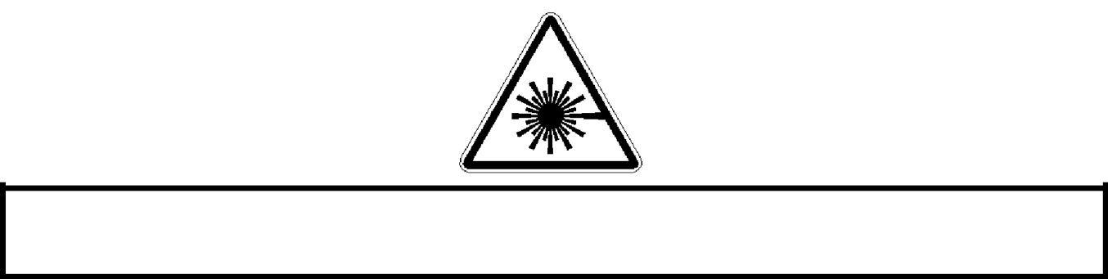

**Warning:** please use the device after careful reading of the User Manual before operation!

**DANGER**

1.) Do not place the handpiece directly towards anyones eyes. This may cause serious or permanent eye damage.

2.) Never look directly at the light

3.) Cover all reflective surfaces prior to powering on the OMNIA machine.

4.) All operators and patients must wear proper eye safety protection.

5.) Do not pull the power cord using force or touch the power plug with a wet hand.

6.) Stop using the product and unplug the power cord immediately when there is lightning.

**Before calling for a Service Check:**

* **Safety interlock switch alarm.**

Check whether the outside casing of the device is opened or closed. Verify whether the remote interlock is attached securely to the back of the device.

* **Water Flow Alarm.**

Check water level in water tank. Check for possible leakage from water

tubes or tank.

* **Water Level Alarm**

Too high or too low of a water level can cause the machine to not function normally.

The clinician should check the water level before turning the machine on. In

the event the machine is on and the water level is too high or too low, the machine

must immediately be turned off to correct.

* **Water Temperature Alarm**

If the water temperature alarm sounds, restart or stop the machine.

**If there are no above mentioned issues, please contact the Aesthetika maintenance department.**

**How to Check or Replace the Power Fuse:**

**Step 1:** Shut down the machine by placing the power switch in the off position.

**Step 2:** Pull out the power cord plugs.

**Step 3:** Use one small flat screwdriver to gently turn the protective tube casing in

in a counterclockwise manner and then take out the protective tube.

**Step 4:** Remove the fuse from the protective sheath.

* Only the fuses with standard type which specified by the manufacturers can be used for replacement (fuse type: 10A/250VAC).

**Step 5:** Put in the fuse tube and the sheath and tighten the sheath clockwise.

**Step 6:** Re-insert the power cord to the back of the machine and plug it in. Then

turn the power and key switch on to verify whether the machine is working

correctly.

**Main Unit Storage and Transport Maintenance:**

If the equipment is not used for a long time it should be covered; this will help prevent dust and water vapor from entering into the inside of the main unit. These pollutants may lead to the decrease of laser output energy, and alter normal operation. The equipment installation sites must be clean, dry and dust-free. The temperature should be maintained at 4 ~ 40 ℃. In order to avoid the appliance casing and components aging, the main unit should not be put in direct sunlight. It should be installed in a dry, ventilated place with no corrosive gasses. In a region with the temperatures below 0 ℃, the cooling water in the main unit should be emptied out prior to the transport process.

**Laser Handpiece Maintenance:**

The laser handle is composed of precision optical components. It should not fall, be dropped and avoid blunt force of any nature. If the laser handle is handled roughly, it may cause damage and the laser module may not emit light normally. The cleanliness of the end plane of the light guide crystal has a significant impact on the laser output, so the inspection and proper cleaning must be given before application. When using the handle transmission system, it should try to avoid the damage caused by extreme bending.

**Cooling System:**

Regularly check to ensure the cooling fan works normally. If the cooling fan fails the machine will overheat. The heat will cause the machine not to work normally and possibly cause damage to the device.

The cooling water used for the machine must be deionized or distilled water with a PH value of water5.5-8, hydronium water resistance: 5ΜΩ/cm2. Change water every 2-3 months.