

User Manual

**Table of Contents**

**Introduction and Purpose of Equipment** ……....…………...………………… page 3

**Specifications Chart** .………………………....………………………….……… page 3

**Installation and Notes**  ……………...……....……………………………...…… page 4

**Accessories List** …………………..…………………………………………...… page 5, 6

**Main Unit and Parts Installation** ……..…………………………………..…… page 6,7

**Startup Procedures** .…………….…………..…………………………...……… page 8,9

**Water Input and Output** …...…………………………………………...……… page 9, 10

**How to Change Water** .………………………………...……………………...… page 10

**Instructions for Replacing the Filter** ....……………………………………..… page 11, 12

**Clinical Operator Display/ Instruction** ……………………………………….... page 13, 14

**Daily Maintenance** .……………….……………………………………..……… page 15

**Fault Alarm** .……………………....………………………………………..…… page 15

**Before Calling for Service Check** .…….………………………………..……… page 15

**How to Check or Replace the Power Fulse** .…………….………………..…… page 15

**Main Unit Storage and Transport Maintenance** .…………………………..… page 16

**More Operative Skills and Precautions** ……………….……………………….. page 16

**Maintenance Reminders**……………………………………………………….... page 17

**Laser Handle Maintenance** .…………………………..……………………..… page 17

**Cooling System** .….……………………………………………….……..……… page 17

**Introduction And Purpose of Equipment**

* The Diode Laser Hair Removal Device’s 808 nm diode laser treatment is a single wavelength. It successfully achieves laser hair removal by delivering high energy into the skin through selectively absorbing energy from the surrounding hair follicles. Through this hair removal process the laser destroys the hair follicle while protecting the surrounding skin. This diode laser can deliver various settings to be safely and comfortably used on all skin types.
* Having an 808nm diode laser allows the clinician to safely and effectively treat all skin types and blsck and brown hair colors. This particular instrument makes treatment on all skin types possible (Fitzpatrick I-VI), it comes equipped with pre-programmed settings and protocols for patient’s comfort, safety, and efficacious treatments.
* Primarily, the wavelength of 808nm diode laser is targeting the chromophore melanin in the hair shaft with a high concentration of energy. This means light energy passes the shaft into the follicle and into the papilla with little to no energy absorbed by the surrounding skin tissue, this process also makes it safer for skin containing more melanin. The distribution of heat throughout the follicles is also achieved through a customized and programmed pulse format, which allows mostly all of the energy to be absorbed into the follicles resulting in destruction of the hair follicle itself.
* Remember: Light, heat, destruction. As this light energy is converted into thermal energy and targeted it destroys the follicles, which destroys the regeneration capacity and permanent hair removal can be achieved.

## Specifications

| Laser type | 808nm diode laser |
| --- | --- |
| Display | 15” color touch LCD screen |
| Laser wavelength | 808nm |
| Treatment laser spot | 12 × 16 mm2 |
| Pulse width | 8 ~685 ms (continuously adjustable) |
| Energy density | 2~120J/cm2 (continuously adjustable) |
| Pulse frequency | 0.5~10Hz |
| Cooling mode | close-cycle water cooling  contact cooling for the lasing head is 0 ~ 30C |
| Power Supply | AC 220/50Hz ; AC 110/60Hz |
| Size | 50*44*110 cm |
| Net weight | 57 kg |
| Packing | Aluminum alloy case |

# Installation & Notes

* Opening the Exterior Packing Box:

1. Turn left the lever 180 degrees to open the lock hinge
2. Flip up the lever, then the packing box can be opened

## Accessories List

* The blow chart depicts what is included with the main unit and accessories of the Diode Laser Hair Removal Instrument.

|  | Name | Photo | Qty. |
| --- | --- | --- | --- |
| 1 | Handpiece & Holder | 未标题-1 | 1 set |
| 2 | Foot Switch (IPX1) | 7.jpg | 1 pc |
| 3 | Safety Goggles  for Patient |  | 1 pair |
| 4 | Safety Goggles for Operator |  | 1 pair |
| 5 | Remote Interlock Switch | 连锁.jpg | 1 pc |
| 6 | Water Filter Core |  | 2 pcs |
| 7 | Power Cord |  | 1 pc |
| 8 | Water Funnel & Pipe |  | 1 set |
| 9 | Water Connector | 2.jpg | 2 pcs |
| 10 | Short Circuit Clip | 夹子.jpg | 1pc |
| 11 | Fuse Tube | 保险丝 | 2 sets |
| 12 | Spanner | 60480f0e6b79c2b54354119f7fede1e | 1 set |

## 

## 1F7Q`V`41O){99KJWHL4[}T

## 

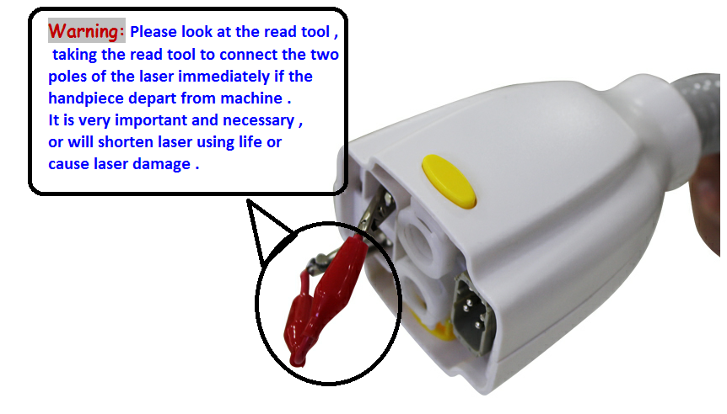

TIP: The laser handpiece is extremely fragile, please take precautions and handle carefully.

 The clinician should not disconnect the handpiece from the machine under any circumstances while the machine is turned on.

The handpiece should only be disconnected from the machine when the machine fans have turned off completely. Once the fans have completely stopped, the machine is completely turned off.

## 

## Startup Procedures

* **How to Move the Display Screen:**
* When the machine arrives, the machine screen and main unit are attached. Lift the display screen up and forward. To do so lift the display screen vertically and also parallel using both hands. Then rotate the screen from back to front in order to adjust it at a suitable angle.
* **How to Install the Handpiece:**

**Step 1:**Remove the protective caps and insert the handpiece into socket as shown in the following pictures.

**Step 2:** Align the pins and press the yellow buttons in to connect. Then release the button and push-in the connector. Be sure to listen for a click, as it signifies it locking in place.

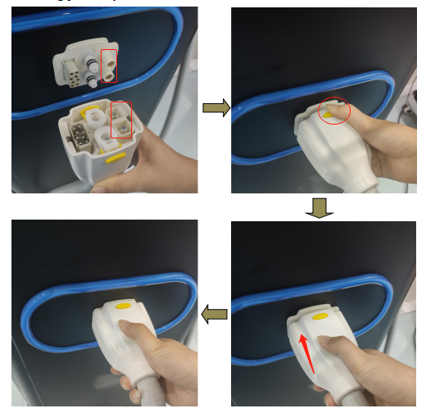

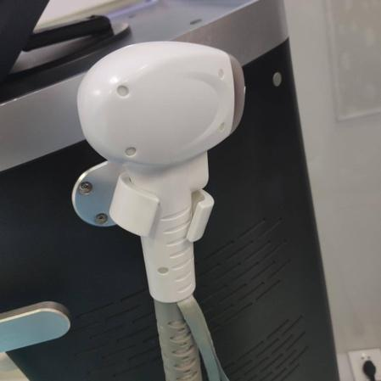

**Step 3:** Once attached, place the handpiece on

the handpiece holder.

* **How to Remove Handpiece:**

Depress the yellow button and wiggle the connector left to right while slightly pulling away from the main body of the device, be sure to do this gently to prevent damaging the connections.

**Water Input and Output**

* **How to input water:**

**Step 1:** Install the water tube with funnel at the water inlet and water overflow connection point.

**Step 2:** Add ONLY distilled water until water spills automatically from water

overflow vent. This indicates there is enough water to operate the machine.

**Power connectors:**

**Step 1:** Connect the power cord, interlock, and pedal. The interlock and pedal

must be aligned precisely with the input to be inserted.

**Step 5:** The air switch must be in the up position. To do so, turn off the emergency

button (make sure the red knob is not depressed inward). Press the machine's button to turn on the machine.

**Step 6:** Turn on the machine and wait for the 1st screen display.

**Step 7:** Wait and check the handpiece glass window after 3 minutes to check that the crystal has adequately chilled. After the sapphire tip is chilled, the clinician may begin using the machine for treatments. If sapphire is not cold, turn off the machine immediately and contact service immediately.. The clinician may not operate the machine or begin treatment if the chill tip is not chilling..

* **How to Change Water:** Distilled water only. The water must be filled at time of machine installation and when needed. A water fill sensor will be illuminated on front screen when needed.

**Step 1:** Turn off the machine.

**Step 2:** Disconnect power supply.

**Step 3:** Add water per earlier instructions in this manual “how to input water”

**Instructions for Replacing the Filter**

The water filter core must be replaced every 3-4 months.

**Step 1:** Begin by opening the panel cover on the back of the machine to expose the

filter.

**Step 2:** Remove the two screws above the filter port. The two silver screws are

located above the filter which are easily visible once you remove the water

filter panel on the back of the machine (**Step 1**).

**The filter is now unlocked and the filter may now be removed.**

**Step 3:** Remove the blue tubes prior to cleaning and changing the water filter. Remove the blue water tubes from each side of the filter by pushing on the black port holding the blue tubes in place. Once the black port has pressure applied, blue tubes will release.

**Step 4:** Once the blue tubes are removed (when **Step 3**  is completed), use the white unlock key for the internal water filter and place it at the bottom of the water filter. Then slide it to the top until it fits snugly. Then turn it counterclockwise to open the filter container and remove the old filter.

**Step 5:** It is strongly advised to thoroughly clean the internal filter cavity after

removal of the previous water filter. Wipe it down with mild soap and water,

making sure to completely dry the container prior to reinstalling the new

water filter.

**Step 6:** To reattach a new internal water filter completely, attach the blue tubes on

each side of the filter by inserting them into the black ports.

TIP:if the blue tubes are difficult to insert into the water filter, apply slight pressure

to the black ports, this should allow for the blue tube to slide in more easily upon

attachment.

**Step 7:** Once the blue water tubes are attached to the black ports slide the new

internal water filter into place.

**Step 8:** Place the water filter lock screw back into position by turning them

counterclockwise, in order to hold the water filter in place.

**Step 9:** Once a new water filter has been placed in the cavity use the white unlock and

lock key to replace the water panel on the back of the machine protecting the

internal water filter. Place the unlock key at the base of the water filter and

slide it up until it fits snugly, then turn it clockwise to lock the filter cap back

in place.

* **Water Filter Visual:**
* **P1:** shows the filter and the wrench to disassemble the filter.
* **P2:** to **P3**: shows how to remove the filter.
* **P4:** Piece pictured after opening. Remove the old filter element and clean the shell, then put the new filter in and tighten it.
* **P5:** New filter.
* **P6:** Displays how to put the new filter in.
* **P7:** Picture after replacing the filter.

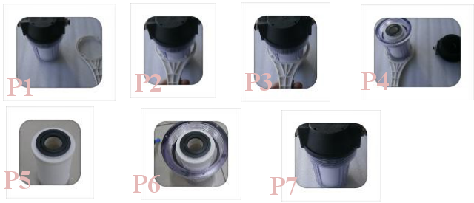



TIP: Only manufacturer authorized maintenance personnel should service the main unit, laser handpiece, foot switch, or any other accessories. If any problems, please contact your local dealer.

TIP: During the storage process, the hair removal machine should be tested once a week. The power-on and off condition for power switch, key switch and emergency stop switch are detected. If this does not occur, disconnect the power supply and contact the manufacturer.

## Clinician/ Operator Display Instruction:

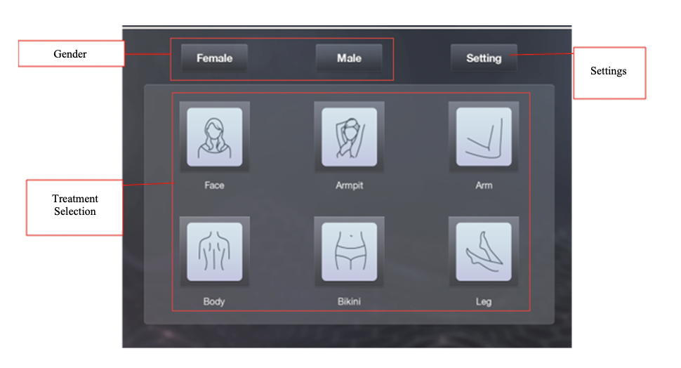

* Power on machine
* Enter through the login page
* Touch display, enter selection on the

function page.

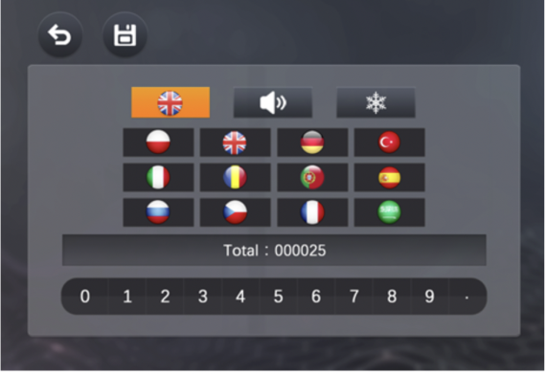

* - (ADD CORRECT PHOTO)

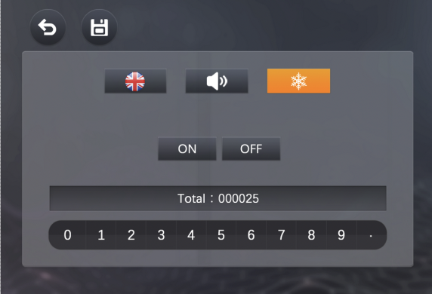

Cooling Setting Page. Snowflake icon can be used to turn on and off colling

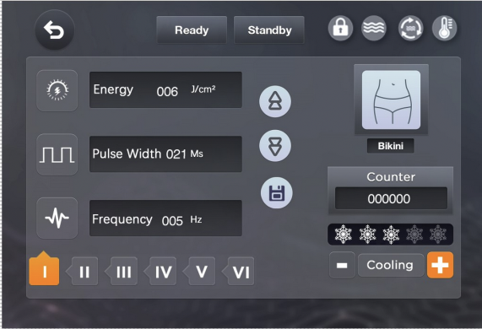

- Selection of Particular Treatment Area

(ex:Bikini Line/ Brazillian Treatment)



- Return Button



- Energy Button: Press up and down arrows to adjust the energy;

range of 1-120J/cm2



- Pulse Width Button: Touch icon button first, press up and down arrows to increase or decrease width of the pulse. This setting is self-matching with energy and frequency. Width pulse, range 8-685



- Frequency Button (Repetition Rate):Touch icon button first, press up and

down arrows to increase or decrease repetition rate. Range 0.5-10Hz



- Skin Typing Selection Button



- Up and Down Selection Arrows: to increase or decrease energy ,

width pulse, or frequency.



- Parameter Save Button



- Interlock Alarm Button



- Water Level Alarm Button



- Water Flow Alarm Button



- Water Temperature Alarm Button



- Cooling for Machine: Press “＋/－” to increase or decrease cooling.

**Daily Maintenance**

* Maintenance is necessary to ensure that the hair removal machine works and is in proper functioning condition. Care must be taken in maintaining the hair removal machine, as the laser is a medical device.

**Fault Alarm**

* The hair removal machine has multiple protection functions including **water flow, water level, water temperature**. When there are abnormal conditions the system will disconnect the laser power and display. Under normal circumstances, the indicator is green. In the event of failure, the indicator shows red and the buzzer will make a continuous alarm sound. Once the fault clearance is detected, the alarm screen and the alarm sound will automatically disappear. If the same warning screen appears more than three times during a treatment, please contact the manufacturer.

**Before Calling for Service Check**

* **Safety interlock switch alarm:** Check and make sure the remote interlock is connected properly.
* **Water Flow Alarm:** Check water tank level. If water full check tank and surrounding area for possible leakage from water lines or tank.
* **Water Level Alarm:** Too high or too low of a water level and the machine will not function normally. Make sure there is enough water in tank before turning the machine on. In the event the machine is on and the water level is too high or too low the machine must immediately be powered down. An air bubble may be inside the water lines.
* **Water Temperature Alarm:** If the water temperature alarm sounds, restart or stop the machine.

**If there are no above mentioned issues, please contact maintenance.**

**How to Check or Replace the Power Fuse**

**Step 1:** Shut down the machine by placing the power switch in the off position.

**Step 2:** Pull out the power cord plugs.

**Step 3:** Use one small flat screwdriver to gently turn the protective tube casing in

a counterclockwise motion, then take out the protective tube.

**Step 4:** Then take out the fuse from the protective sheath.

* Only standard type fuses which are specified by the manufacturers and approved for replacement (fuse type: 10A/250VAC).

**Step 5:** Put in the fuse tube and the sheath, then tighten the sheath clockwise.

**Step 6:** Re-insert the power cord to the back of the machine and plug it in. Then

turn the power and key switch on to verify the machine is working correctly.

**Main Unit Storage and Transport Maintenance**

* If the equipment is not used for a long time it should be covered; this will help prevent dust and water vapor from getting in. These pollutants can lead to the decrease of laser output energy, and alter normal operation. The equipment installation sites must be clean, dry and dust-free. The temperature should be maintained at 4 ~ 40 ℃. In order to avoid the appliance casing and components aging, the main unit should not be put in direct sunlight. It should be installed in a dry, ventilated place with no corrosive gases. In a region with the temperatures below

0 ℃, likewise the cooling water in the main unit should be emptied out prior to transporting the machine.

**808 nm Diode Laser Hair Removal Machine:**

**More Operative Skills and Precautions**

* Upon uncrating the device, before use, only add DISTILLED to the laser

machine. The alarm will sound if the water level is too low or if there is air inside the water lines. If this happens, simply add water until the alarm has stopped. This may require about 2-3 liters.

* If it is the first time operating the device, turn it on and off 2-3 times, in order to let the water circulation cycle through the machine fully.
* When the machine is on, ensure the room temperature is controlled between

68° F to 79° F.

* When doing a treatment, the handpiece must be applied with gentle pressure to ensure full contact with the skin. If there is a gap, some light energy may be lost, thus resulting in less efficacious results.
* When deciding how to select appropriate clinical settings for the device for treatment the clinician must consider the following: skin color, hair color, hair thickness.

**Maintenance Reminders**

TIP: The clinician must change the water every 1-2 months in accordance with how often the machine is used.

TIP: The filter must be changed every 3-6 months also in accordance with how often the machine is used. If the clinician notices the filter is dirty before the 3 month mark it may be changed. Store filters in a dry and ventilated place.

TIP: After each treatment, wipe the handpiece head with Cavicide, making sure to thoroughly clean the front glass. This will prevent debris and dust from causing damage to the glass lens. If this is not done it is possible the debris and dust will cause burning in following treatments.

TIP: The clinician must put the handpiece in the handpiece holder securely when finished with cleaning after treatment, so that the handpiece does not fall as this may damage it.

**Laser Handle Maintenance**

* The handpiece is composed of precision optical components. It should not fall, be dropped, and at all costs avoid blunt force of any nature. If the laser handle is handled roughly it may cause the laser module to not emit laser light normally.
* The cleanliness of the crystal has a significant impact on the laser output, so inspection and proper cleaning must be done before application.
* Avoid damage caused by extreme bending the tube attached to the handpiece.

**Cooling System**

* Regularly check to ensure the cooling fan works normally. If the cooling fan fails the machine will overheat. The heat will cause the machine not to work normally and possibly cause damage to the device.

The cooling water used for the machine must be deionized or distilled water with a PH value of water5.5-8, hydronium water resistance: 5ΜΩ/cm2. Change water every 2-3 months.